Object Oriented Programming

Assignment

CIT has long required a Hotel to allow students and overworked lecturers a place to stay late at night. You are required to create a menu driven hotel system to allow management to rent rooms out to clients.

The system will control 15 rooms (3 suites, 6 doubles, 6 singles). Each room has a rate per night per person, indicator whether it is in use, max guests and current occupant of room is in use.
- Suite can hold 3 guests
  - Rate is 150 pp per night
- Doubles can hold 2 people
  - Rate is 100 pp per night
- Singles hold 1 person
  - Rate is 75 per night
Max 27 occupants in hotel per night.

The system has the following basic functions:
- Reservations
  - Add a new reservation
    - A reservation will be either from a student or a lecturer
    - Once a reservation is made the room is no longer available
  - Cancel a Reservation
    - A room becomes available once reservation is cancelled
    - Guest is removed from system once reservation cancelled
  - Display all Reservations
- Display All current guests
  - By Lecturer or by Student
- Display all available Rooms
- Process a new reservation
  - Get the guest details
  - Give option of room
    - Check room availability
  - Lecturers get 10% discount on room rate
- Display Payments
  - Process a payment
    - A room becomes available once payment is received
    - Guest is removed from system payment is received
  - Outstanding Payments
- Exit the system
  - Asks the user to save the current system
  - Save to file
    - Reads from file if file exists on startup to load objects into the system.
The following are expected to be used in the code
  - Packages
  - Good programming standards
  - OOP concepts
  - Comments – Indicating what methods are supposed to be doing ect.
    - Very useful to readers when grading code to know what a programmer was doing when creating a methid.
  - Exception handling
    - Use your own Exception where applicable
  - Indentation
    - I will fail you for this 😊
  - Naming standards
  - Collections
    - Arraylist ect..
  - Read/Save to file
Below are examples of what your menu’s could look like
Main menu

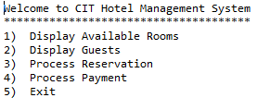

Reservations Menu
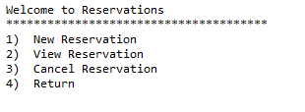
Hand up date midnight 17-12-2017 on blackboard, any later submissions must be done so through email to Diarmuid.McCarthy@CIT.ie
Any assignments handed in after this time will be subject to 10% penalty.

